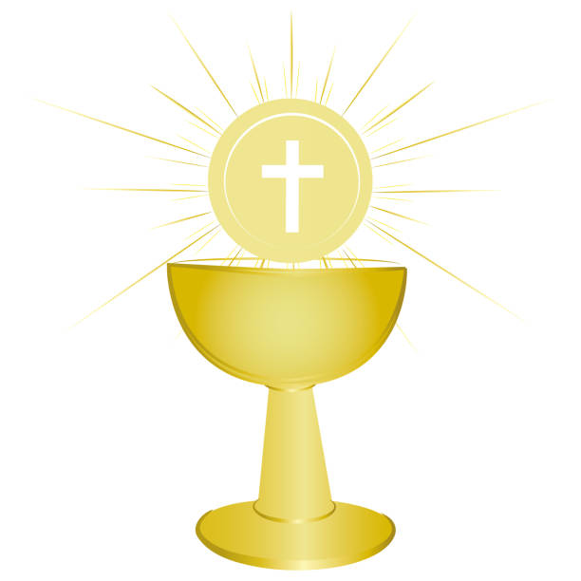Week of 8/20/19

St. Margaret School
MISSION STATEMENT
St. Margaret School will provide a firm educational foundation of religious values and academic knowledge for each student in a ​Catholic, ​nurturing environment.
Ms. Eshbaugh’s Third and Fourth Grade Class

Everything We Learned This Week:

Reading: We worked on our reading stamina and discussed the many ways we can remain focused while reading. Additionally, we began reading the book, Because of Winn-Dixie by Kate DiCamillo, focusing on characters and main ideas.
Writing: We began our Narrative writing unit.
Theology: We set our faith goals for this year, discussing the ways in which we want to continue to grow in our faith as well as how we plan to accomplish our goals. We also learned more about the story of Creation and created storyboards that represented each part of the story (In the Beginning, The Test, A Sad Ending, and The Promise of a New Beginning). Additionally, we attended Mass on Tuesday and Friday. We also participated in Adoration on Thursday.

Third Grade Math: We reviewed telling time, place value, mentally adding/subtracting 10 or 100 to a given number, and skip counting.
Fourth Grade Math: We reviewed telling time, multiplication facts, division facts, and rounding.
Science: Unit 1: Plant and Animal Structures; What Plant Structures are Used for Support and Growth?

Upcoming Events/Important Notes:

- August 26th: Rosary Moms from 9-9:50 A.M.
- August 30th and September 2nd: No School; Labor Day
- September 30^{th:} Scholastic book order forms are due
- “Feed Our Friends” Day will now be held on every Thursday of this year. If students donate $1 for our friends in Haiti, they can dress in casual clothes instead of their uniforms.

